**Excel Assignment – 16**

1. What is a Macro? How is it useful in excel or in your daily work?

Answer:  A macro is an action or a set of actions that you can run as many times as you want.

It helps in doing repetitive actions in excel on daily basis. When you create a macro, you are recording your mouse clicks and keystrokes.

1. What is VBA? Write its full form and briefly explain why VBA is used in excel?

Answer: Visual Basic for Applications is a computer programming language developed and owned by Microsoft. With VBA you can create macros to automate repetitive word- and data-processing functions, and generate custom forms, graphs, and reports.

1. How do you record a macro? Write detailed steps to create a macro to automatically make the following table in bold and to create borders for it in excel.

hi 78

hello 69

ineuron 45

Answer:

Step1:

1. First go to developer then click for use relative references and go for Record macro.

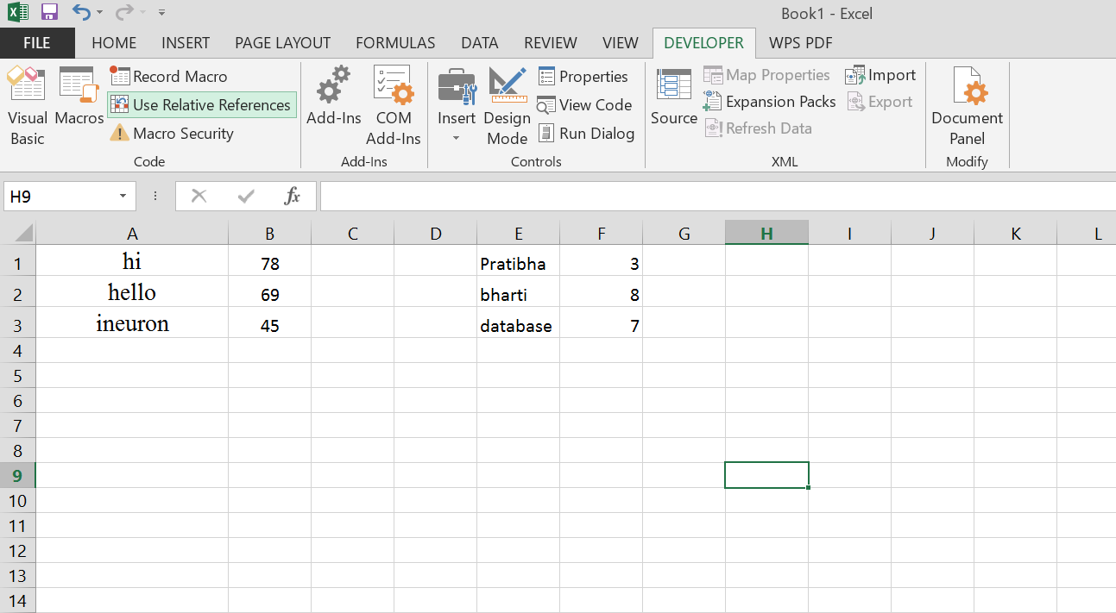

1. As you click for record a macro, name as comfortable

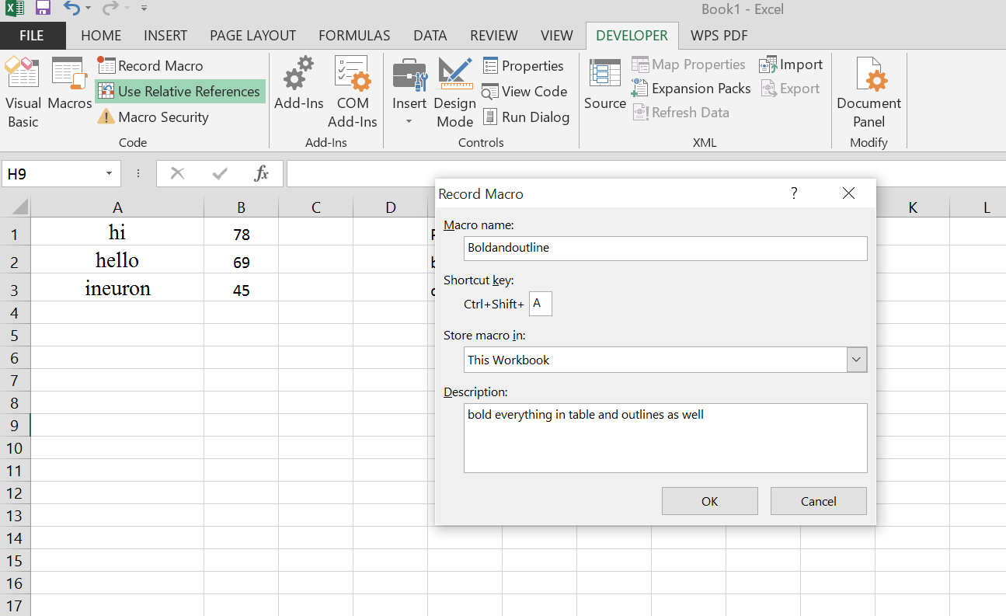

1. Bold and outline a demo table and then click stop recording.

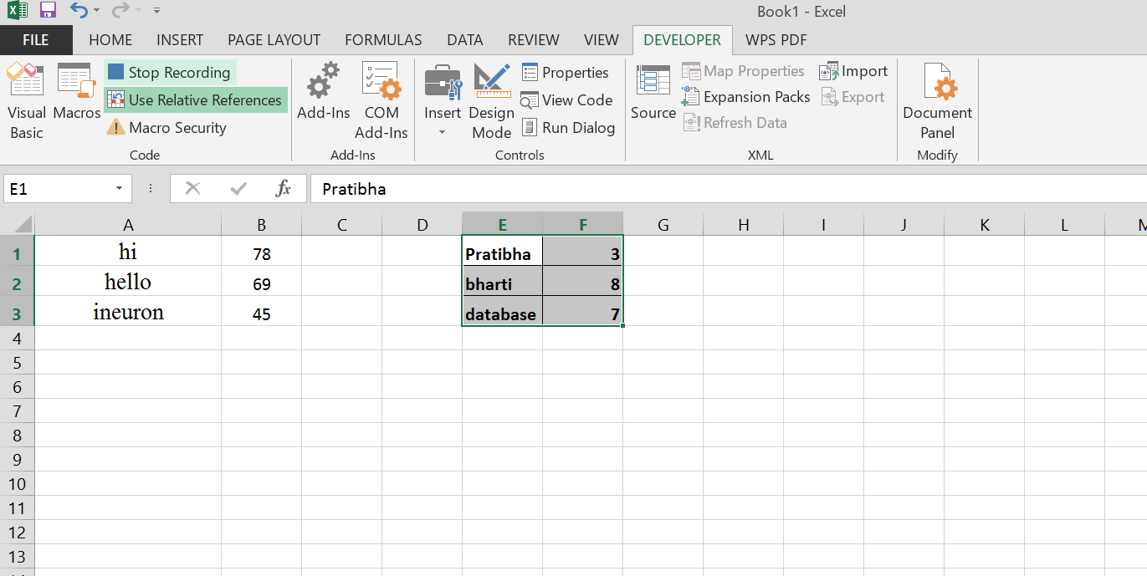

1. Click the shortcut created for macro and see the desired results.

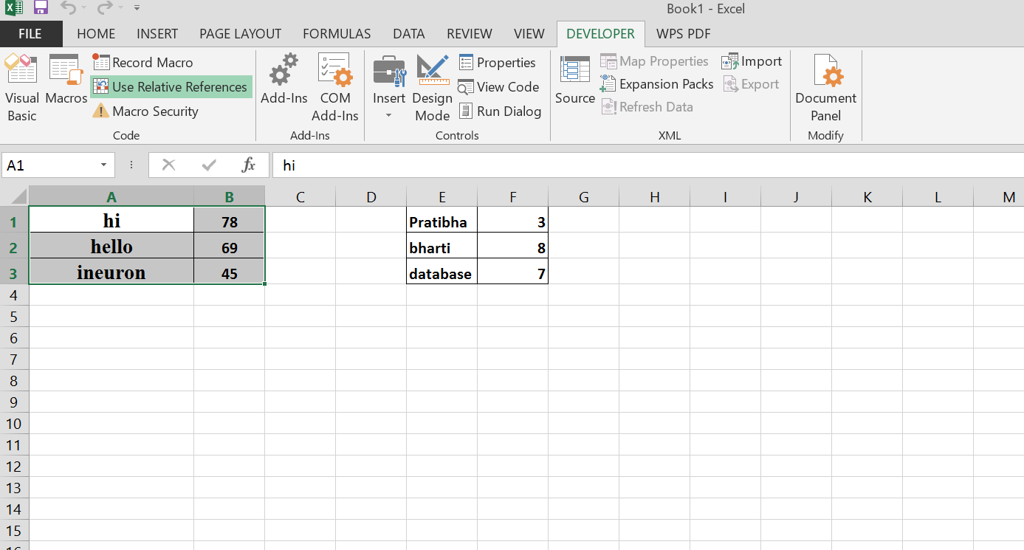

1. What do you mean when we say VBA Editor?

Answer: VBA Editor is a place where we write VBA code and create macros. Whatever the code we write will be in the background to the excel file with which it is linked, and once we run the code, every process will happen in the background and what we see is the output in the excel file.

1. Briefly describe the interface of a VBA editor? What is properties window? And what is watch window? How do you display these windows?

Answer: 6 main components of the Visual Basic Editor:

1. Menu bar
2. Tool bar
3. Project window/ project explorer
4. Properties window
5. Immediate window
6. Programming window/code window/Module window

The Properties Window displays the properties of the object that is currently selectedin the Project Explorer and allows you to edit those properties.

The Watch Window makes it convenient to inspect, audit, or confirm formula calculations and results in large worksheets. By using the Watch Window, you don't need to repeatedly scroll or go to different parts of your worksheet.

To display Properties window:

* Click on “Visual Basic” in the Developer tab of [the Ribbon](https://powerspreadsheets.com/custom-excel-ribbon/)
* Clicking on “Properties Window” within the View menu.
* Clicking on the Properties Window icon.
* Using the “F4” keyboard shortcut.

To display Watch window

1. Select the cells that you want to watch.

To select all cells on a worksheet with formulas, on the Home tab, in the Editing group, click Find & Replace, click Go To Special, and then click Formulas.

1. On the Formulas tab, in the Formula Auditing group, click Watch Window.

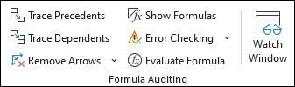

1. Click Add Watch Button image.
2. Click Add.

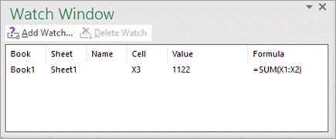

1. What is an immediate Window and what is it used for?

Answer: The Immediate window is used to debug and evaluate expressions, execute statements, print variable values, and so forth. It allows to enter expressions to be evaluated or executed by the development language during debugging.